Getting a job in Animation

INTRODUCTION

This is meant to be as a small guide to help people who want to work in the Television Animation Industry in the United States.
I’m going to try to write this for people who have no ties to the industry, someone who wants to know what they can do to join the animation workforce. I’m writing this for people who did not attend art school and did not have the opportunity to network with people in real life.

A little about myself- I have been working in Animation for a little over 7 years as a Revisionist and Storyboard Artist- and can only speak on what I’ve experienced, so I asked a friend of mine, who is a Creative Executive, what advice they have to give.

I also asked on twitter if people had any questions and they were answered here as well.

We are both POC and have experienced the industry in different ways. My friend has been in the animation industry around 8 years, working as an assistant for two of them, but still working in development.

Let’s begin!

WHAT DO YOU LOOK FOR

Searching for animation jobs can lead to studio job listings online. But the listings have short, matter of fact, statements for what they look for. It can seem daunting and rigid.

Undeniably, the first and most important part is your portfolio.
What should be in it?
(I am not someone with hiring power but these are some things that have helped me land jobs.)

If you know the production you are submitting for, I recommend tailoring your portfolio to show that you can match the show’s sensibility. This doesn’t mean you have to change your art to match the visual style- but if the show is a comedy, include comedy samples. If it’s action- include action etcetc.
Whenever I submit for a position I rotate out my samples based on what I am applying for.
If it’s a kids board driven comedy- I include a sample from something that I did that fits the requirement.
If it’s a scripted adult show- I include samples that show off how I can stage scenes to enhance the written word.

If the job listing doesn’t give any information beyond the generic ‘strong storytelling skills’ etcetc. Put in what YOU want to draw.

How do you build a storyboard portfolio if you have never worked on a show?

You must draw your own boards. BUT they can be anything-

-Keep things between 20-90 panels.
-Make sure that there is at least one interesting beat in there- a joke, an emotional change, a shift of power- something that shows you can move a story forward.
-If writing your own dialogue seems daunting there are tons of scripts online you can work from if you need a scene to draw. (I listen to a D&D podcast and boarded out a scene from there and it helped me land a job. So even if you feel like something is too close to the realm of fanart- you can use it to your advantage)
- Board a scene or conversation from real life!
-They don’t all need to be super clean and polished- having a couple clean panels every so often is enough to trick the eye into thinking it’s all the same level of finished.

Having two to three varying boards will beef up your portfolio.

REJECTION
Unfortunately, animation is not yet at the point where they can effectively communicate feedback. You can be left with no news for weeks, months and even years(!)

This is something that leadership needs to address. But for informational purposes to the person reading this- that is what could potentially happen after applying.

That being said- Rejection does not mean that your only chance is gone. It can be a long process to navigate.

BUT here are parts of the conversation I had with my Exec friend that hopefully will help.
(Some of these questions were from Twitter)

“Do you need a degree?”
NO.
My exec friend said to submit your work regardless.
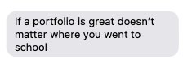
I know many people who did not go to school/dropped out of high school/college/changed career paths.
Artists who have attended school will have an advantage because this is what they are training for every day. If you are not taking formal classes it will be necessary for you to constantly elevate your skills. This is an extremely competitive industry.

I would not be writing this if needing a degree was a cold hard rule.

DO NOT LET SEEING ‘COLLEGE DEGREE’ ON A JOB LISTING STOP YOU IF YOU DO NOT HAVE A DEGREE. YOU ARE NOT DRAWING WITH A PEN MADE OUT OF A DIPLOMA.
The point of a College degree in animation, I feel, is to signal that you had training and have built up some skill. HOWEVER, all it tends to do is discourage talent who don’t have the same resources, even if studios don’t realize it.

“What skills/jobs look good on a resume if you haven't had any jobs in a creative field (hr and customer service for me) and where to find entry level jobs or internships that lead to storyboarding, or how to stand out and get picked over candidates with prior experience”
(I will post the links for entry level jobs in a separate section)

Your portfolio is your strongest weapon for sure. However, if you’re writing a resume consider adding anything you did that can be viewed as work. If you run an online shop- if you table at conventions- if you draw commissions- print your own comics- put a sketchbook pdf online for people to download.
All of these things show that you are able to get things done. I worked in customer service for over 10 years. My resume included every single self published comic I’d ever made, even if it was just 4 copies.

My exec friend chimes in:
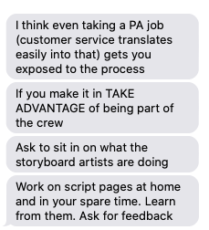
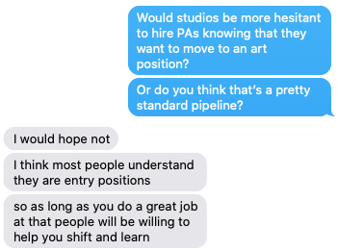

“What quality do remote applicants (foreign or otherwise) need to have that will convince recruiters to hire them?”

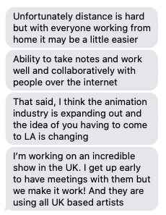
I am not someone with hiring power so I can’t really add to this conversation.

“WHERE do you find talent- HOW do you hear about it-what do you look for- what makes someone stand out- is it drawing? Storytelling? Range of styles? Big online presence?”

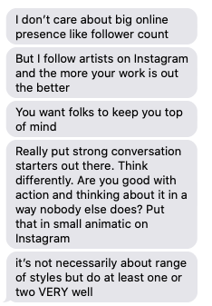

They then mentioned a scene from something that is NDA but the advice at the end is:

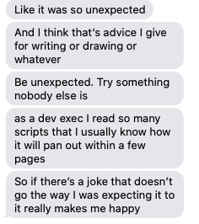

Applying online at studios is ONE way to get your foot in the door.

Which brings us to-

NETWORKING

The following is meant as a guide for what could be useful if you manage to meet with an exec. Networking with artists is similar, but I feel as though there is no real way to know how to behave when you meet someone who is in charge.

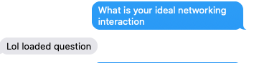

Networking is hard. You’re selling yourself but also trying to genuinely make a connection.

Conventions are a great place to Network, but it is also an overwhelming experience. All of these things take time and money.

Attend panels hosted by execs- get to know their faces, hear what they have to say about themselves, how they approach story and animation and figure out if you want to work with them.

There are execs there who are actively looking for talent. That is their whole job, they want to meet you. But what can you do to make sure that it’s a positive interaction?

A simple introduction as well as-

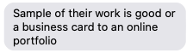
If you are working to get hired- you are hoping to build a relationship that will last your whole career.
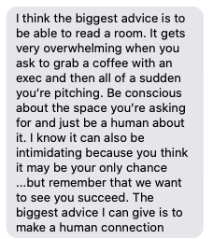

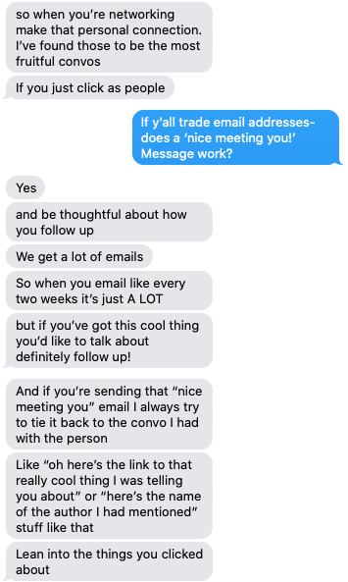

I asked a question about hiring timelines after finding an artist you like, and it’s not really something that they can answer, but I reworded it in a way that is more applicable.

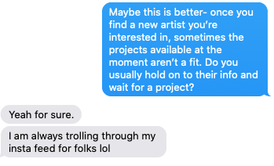

WHAT HAPPENS NEXT?

After applying/interviewing networking what have you- The next round involves TESTING.

Storyboard Testing is a complicated subject, the Animation Guild testing committee has been working for years to streamline the process but it’s difficult to track every test being sent out.
https://animationguild.org/

You will usually sign a non-disclosure agreement and receive a PDF with information on what the test is.
It can be assignment such as “ Draw characters x,y,x in this situation and how they resolve it”
It can be boarding a part of a script-
I’ve seen a few tests where it’s just drawing the main character in fun poses- the point of a test like that is to see if you can really capture the tone of the character’s personality.

*VERY RARELY DO YOU GET OFFERED A POSITION ON PORTFOLIO ALONE.*

Tests should not take longer than a day. Abusive tests do exist- so if you feel overwhelmed- be aware that this is not something that should be happening. If you are in the animation guild REPORT IT.

If you are not in the guild, please do not think that this is your only chance.

*IF YOU ARE GIVEN A TEST FOR AN UNAIRED SHOW DO NOT POST IT OR PUT IT IN YOUR PORTFOLIO UNTIL AFTER IT AIRS*

It’s no good to break NDA before you even get a chance to get hired.

Alternatively- Pitching your own ideas for a show~

After making contact with a studio executive, they may ask if you have anything that you’d like to pitch.

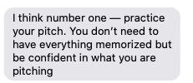
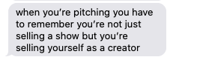
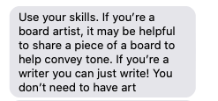

Have an Elevator Pitch ready- What that means is one to three sentences- a story you can easily tell when you’re riding from the 3rd to 1st floor of a convention elevator.

*this is writing advice and i’m not a full time writer BUT

Research Log Lines to media that you enjoy.
Log lines are the quick summaries of tv shows or movies that give you a quick glimpse as to what your story is about.
Most log lines are on IMDB- It’ll help you get a feel for how they are structured. It’s important to have this memorized.
Idk- example from Pacific Rim:
“As a war between humankind and monstrous sea creatures wages on, a former pilot and a trainee are paired up to drive a seemingly obsolete special weapon in a desperate effort to save the world from the apocalypse.”

(i hope this makes sense this is not my area of expertise)

It’s important to also know what shows and stories exist out there already. Studios have many projects in production and a rejection for one idea doesn’t mean a rejection of you as a person.

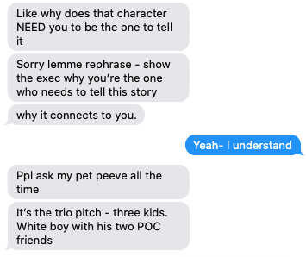
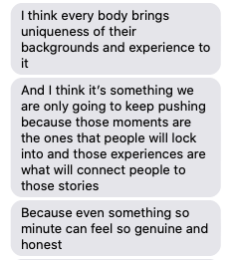

PITCH BIBLE

A Pitch Bible is your document that contains what your show is.
I recommend checking out the Adventure Time Bible to get an idea of how it’s structured.

https://www.scribd.com/document/3122798/Adventure-Time-series-presentation#from_embed

You can see how the first thing you read is the show summary as well as the relationship between the main characters.

You want you pitch bible to clearly communicate to the world what you want to do. These characters have been with you and you are introducing them to strangers for the first time.

Not all pitch bibles need drawings- but they do need to convey story.
I recommend searching for your favorite show and seeing if their pitch bible is online-

TRUTHS

Thanks for sticking with me to the end- I have a list of links coming up that should be some extra help- but before I get to that I want to touch on a very important subject.
How to protect yourself.
Animation is just like any other place in the world. All forms of discrimination can and do exist. It is important to protect yourself- your mental health is not worth losing over drawing cartoons.

It is a snails pace change-

My personal experience has been- starting on a show where colleagues mentioned that this was the first time they worked on a production with female board artists- to now, 7 years later, where one of my recent bosses was a WOC. I’ve gone from hearing slurs tossed out as jokes- to seeing people being fired same day as soon as someone speaks out.

My exec friend- who is also a POC spoke about some conscious efforts that they are working on.

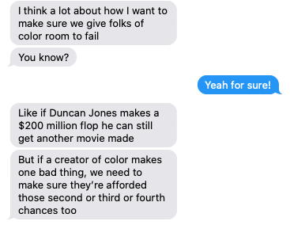

The current studio they are at has implemented hiring practices that are a conscious effort to change how animation looks- inside and outside. We are in the process of seeing more and more studios put a conscious effort to their hiring practices for both executives and artists. We have more work to do but it is a start.
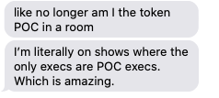

Animation is a small industry behind a locked door. The changes necessary would require that door to be completely obliterated- and until then all we can do is hold the door open.

If you’re reading this and are in the industry I would urge you to do the same. When your show is staffing up be conscious of what you are putting on screen and if it reflects the crew working on it. When you are hiring new talent- are you being responsible and actually doing the work to make the changes you believe in?
Words like this have been similarly repeated for years- but where is the follow through.

The reason things are not changing is because you are too scared to take a risk on someone because you think they don’t have the background that you consider ‘standard’.

Thanks for listening-

ONTO THE

LINKS
*these are all studios based out of California- there are many places around the country but unfortunately I do not know them all

Every major animation studio has a job listing site- they’ll have all their openings as well as internships/trainee programs up there (usually! Sometimes they can be hidden or have their own dedicated page outside of the regular one.

For internships- being a student is required.

CHECK THESE EVERY DAY.

Nickelodeon Animation Studio:

https://www.nickanimation.com/work-here

https://www.nickanimation.com/nickelodeon-internship-program

Disney TV Animation:

https://jobs.disneycareers.com/category/disney-television-animation-jobs/391-1635/55464/1

Disney Feature:

https://www.disneyanimation.com/careers

(I have not worked in Feature Animation before- I recommend Natalie Nourigat’s book ‘I Moved to Los Angeles to Work in Animation’ for further information- https://www.powells.com/book/-9781684152919

Cartoon Network Studios:

https://www.cartoonnetworkstudios.com/jobs

https://www.cartoonnetworkstudios.com/internships

Sony Pictures Animation:

https://www.sonypicturesanimation.com/jobs.html

Titmouse:

https://titmouse.net/careers/

Bento Box:
https://jobs.lever.co/bentoboxent

Netflix Animation:
https://www.netflixanimation.com/jobs

AND MUCH MORE
https://animationguild.org/about-the-guild/studio-list/

This is for after getting hired, but anyone that experiences workplace harassment can call this attorney: https://nosexualharassment.com/los-angeles-san-francisco-sexual-harassment-attorneys/
he spoke at the union and said consultation calls are FREE

ORIGINAL THREAD

This is a continuation from a twitter thread but I wanted to add the original resources here as well.
I’m also going to add extra links to resources that were shared in the comments, some of them i had never heard about myself!

A thread by mads
*for any black creatives wanting to storyboard but not exactly knowing WHAT to study or WHERE- this is what helped me navigate. I did not go to school for art or animation- I learned and am still learning on the job and these are the resources that have helped me most (thread)
*Some of these resources cost a lot of money, and I wasn't able to afford them until after I started working- some of them are free. I am also a slow learner and some of these things could be very obvious. Learning to draw-
*This gesture drawing course helped me not only speed up but communicate my ideas and acting (schoolism.com/school.php?id=…)
*I personally get the most joy out of drawing figures- here are some life drawing sites that can help. (disclaimer- nudity). (quickposes.com/en/gestures/ti…) (youtube.com/channel/UCOVNv…)

*If you are like me, who didn't go to art school- there's a lot of catching up to do to people who had the chance to do this for literal years. But just like any skill- it can be learned.
*I find gesture and life drawing to be most fun and productive when I set the mood- put on an epic movie soundtrack, come up with the narrative and situation for the person you're drawing. I find it much easier to catalogue poses and gestures this way.
*Ok, but also, what if you want to pitch an idea? what does a pitch bible look like? what does a storyboard look like?(scribd.com) has pitch bibles and boards up for a LOT of shows. Unlimited access has a monthly fee however.

*Every Frame a Painting is a gem of a resource.Get a notebook and take notes- this is a classroom- keep your notebook handy- reference it. (youtube.com/results?search…)
*Watch your favorite movie and pause to thumbnail out the compositions. Watch video essays on your favorite live action directors. Take notes! I recently got the criterion channel and have been devouring movies. It's so handy having them organized by specific categories
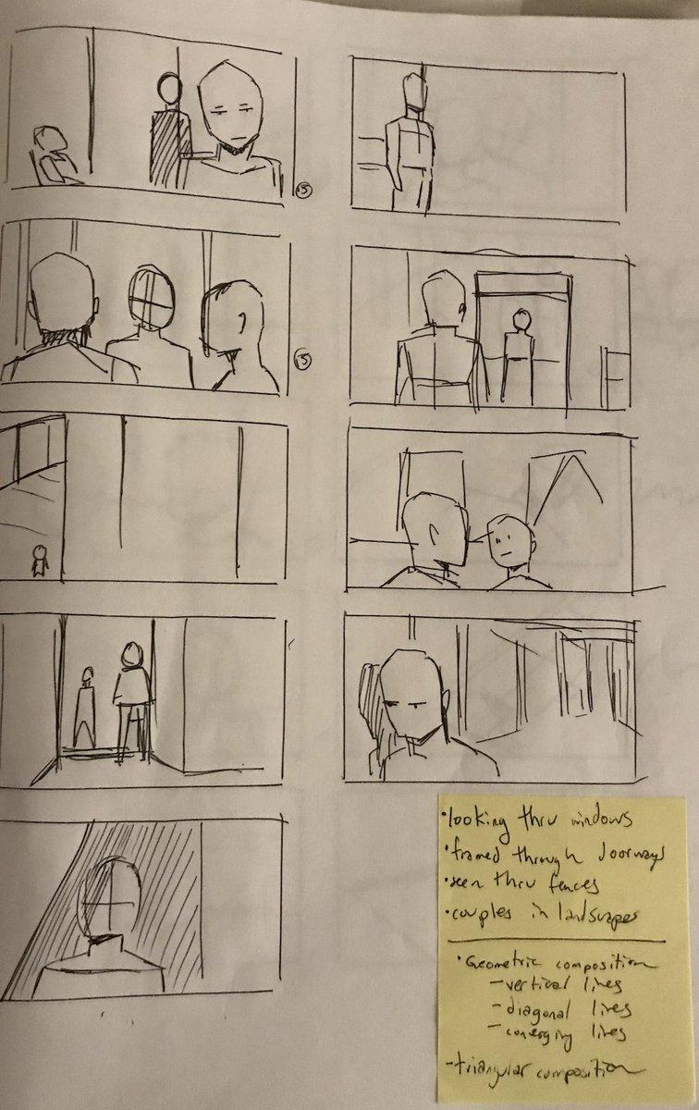

*This first time I got a storyboard test i had NO IDEA WTF I NEEDED TO DO. Trying to learn the jargon of storyboarding was the HARDEST part. I knew how to draw, I knew how to tell a story- but how do I speak the language? This helped SO MUCH. (animationmeat.com/pdf/television…)
*And the cherry on top (but alas the most expensive) But this was the first time I saw a class just TEACH what I wanted to learn. I was able to afford this because I had already been working (artofsteveahn.com/item/action-ad…)
*Idk what to say about this one- I was able to attend this lecture once and it unlocked my brain (expensive, but parts of it are on youtube for free) (kazoneonline.com/p/figures-in-p…)
*ALSO- a thing I can't link because it's different for everyone BUT- GET A PINTEREST ACCOUNT. Search cinematography, Search composition, Search Poses- save them, draw them.
*(personal nonsense)I'm still learning and have very personal goals that I'm trying to accomplish and I'm cheesy and start each sketchbook with a motivational quote just so every time I pick it up I know what I'm working towards.
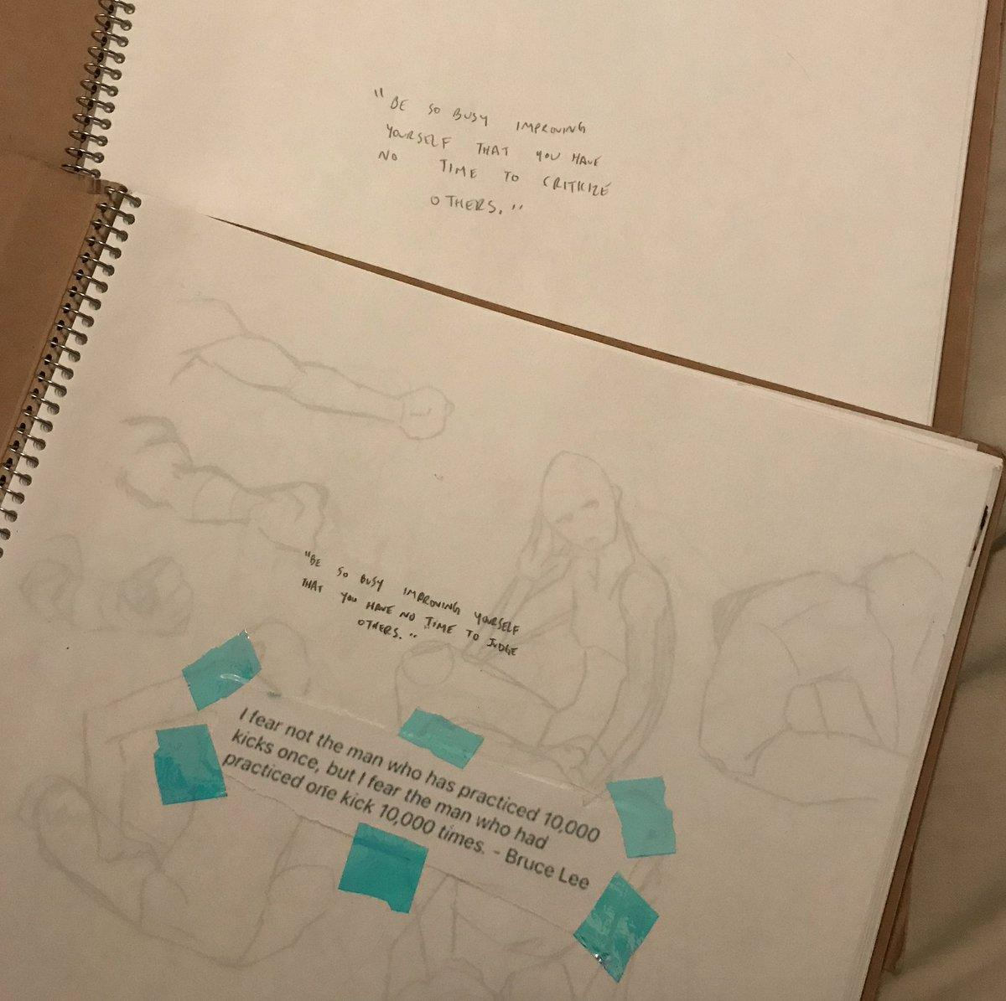
*If I have any other things I'll add them! I'll do my best if anyone has any follow up questions. Stay safe. ALSO~!
*The standard program we use at most tv studios is Storyboard Pro. It is very expensive- If you are interested- please watch some tutorials on youtube first and sign up for the free trial.
* I know some people that can board in photoshop. BUT- some studios will also teach you the program/offer courses. GETTING HIRED is a completely different beast and I think I'll try to compile another set of resources for tomorrow since it's a very different process.

LINKS FROM THE COMMENTS

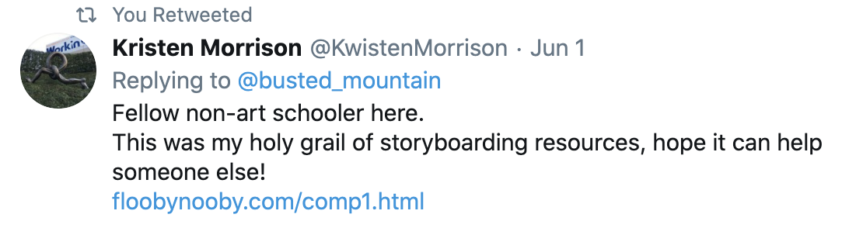

http://www.floobynooby.com/comp1.html

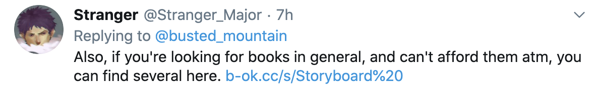

https://b-ok.cc/s/Storyboard%20

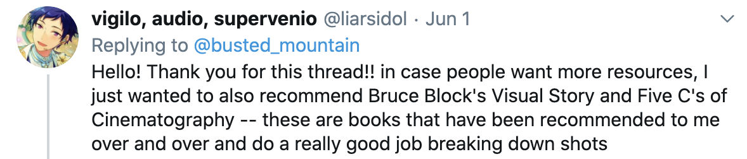

https://www.powells.com/book/-9780240807799
(ALSO CHECK YOUR LIBRARY)

YOUTUBE:
(not all are related to animation- but more for art skills)

DWOO
He has so much information up and available!
https://www.youtube.com/user/spiffsterx

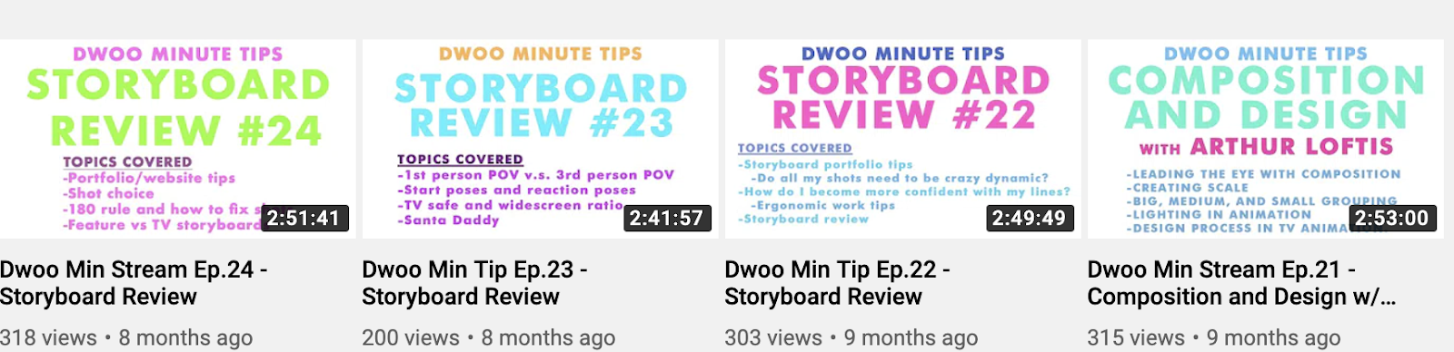

WHYT MANGA
https://www.youtube.com/channel/UCvMBMKniUFj89VwhH-MOG8w
This isn’t purely animation but his drawing tips are so useful. He also speaks about what it’s like publishing comics

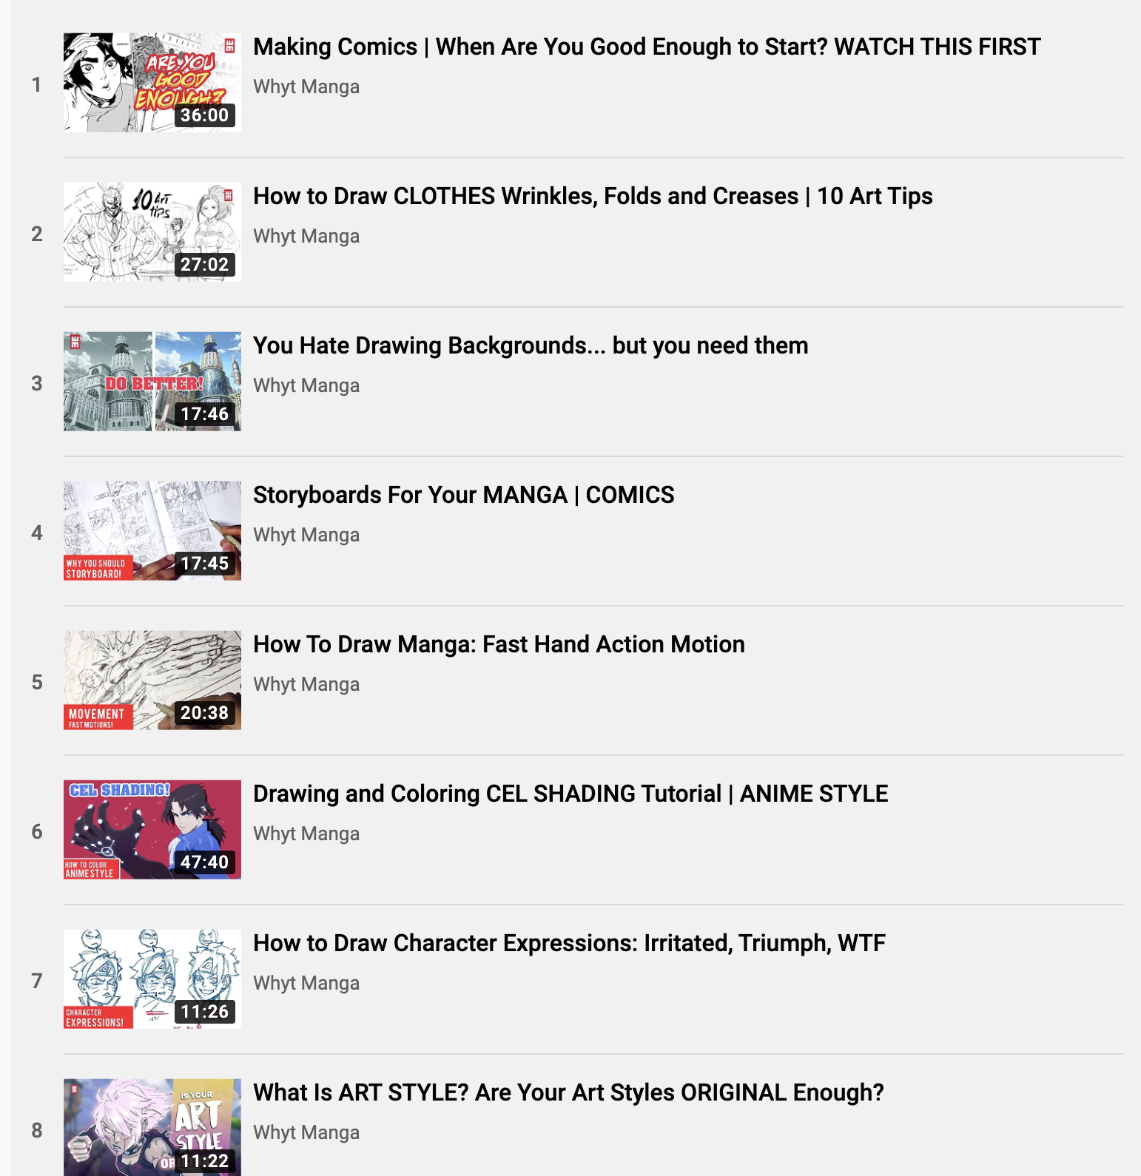

NURI DURR
Really like watching how he explains his approach and how he problem solves.

https://www.youtube.com/user/NuriDurr

https://www.twitch.tv/actionhankbeard
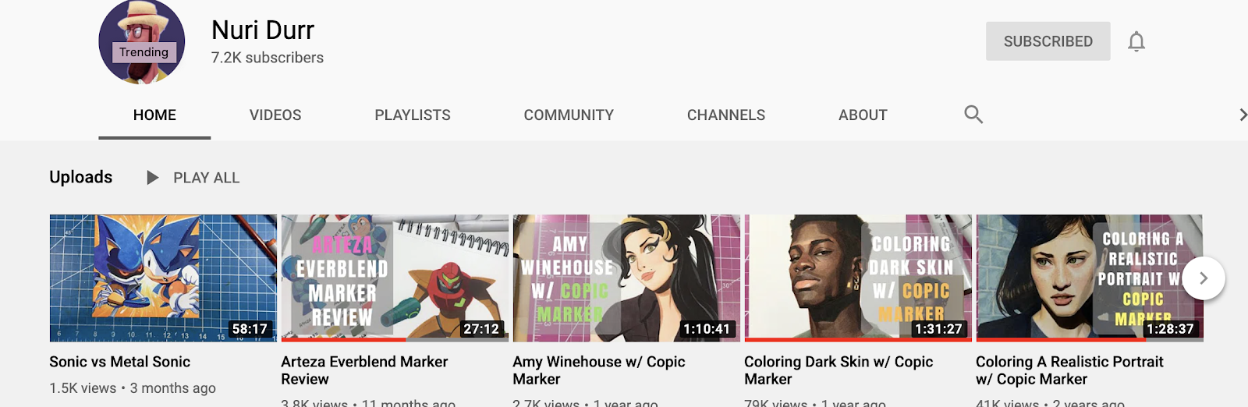

HOBBES SAKUGA
https://www.youtube.com/user/besahdj/
Tab thru frame by frame of some of your favorite animated scenes, take note of who animated them. (hell- make a day of it, eat your favorite food, put on your favorite clothes- anything to get you in the zone)
STUDY THEM.
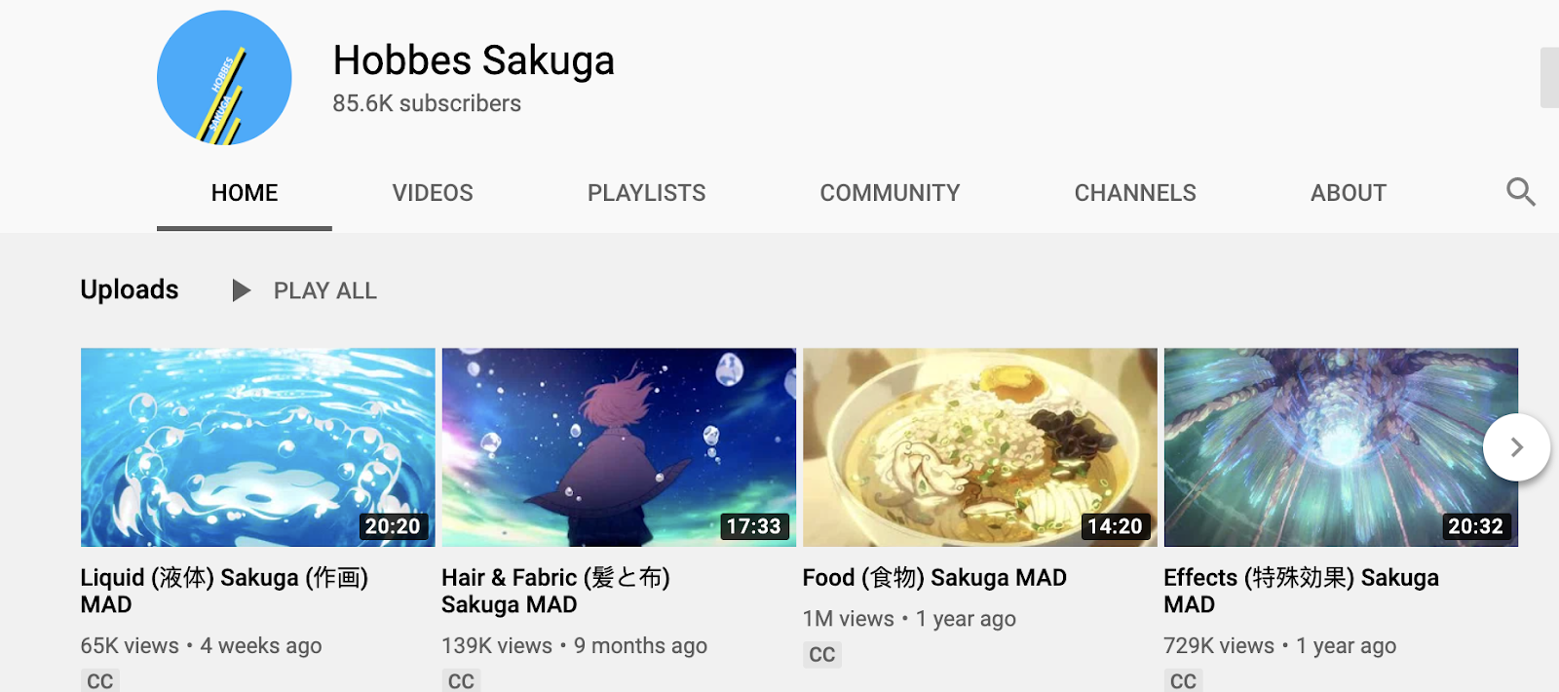

SAKUGABOORU
https://www.sakugabooru.com/post
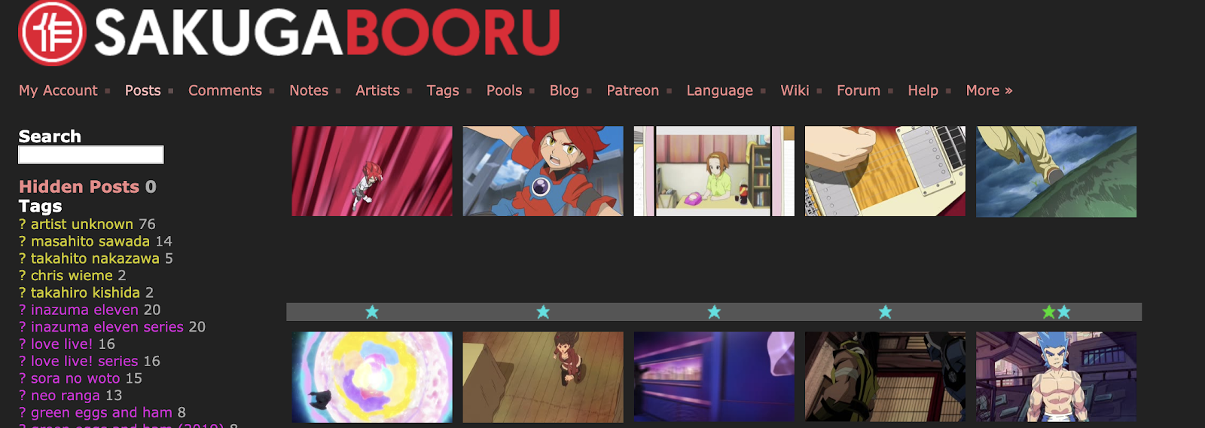

PODCAST
BLACK N’ ANIMATED
They cover a wide variety of topics as well as career paths in animation.
https://blacknanimated.podbean.com/
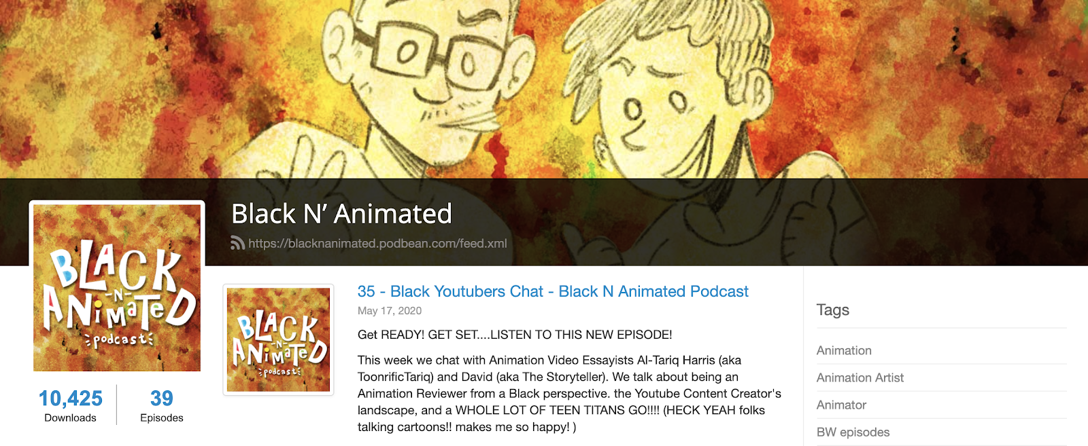

- I’ll keep adding to this list- I love finding and talking about resources!

3D RESOURCES

Resources:

https://www.11secondclub.com/ (Forums for community learning animation critique, contests for feedback from professionals, etc.)
https://www.highend3d.com/ (You can find resources for 3D rigs, models, scripts, tools, etc. here, some for free, some paid for)
http://animationbuffet.blogspot.com/ (A big directory for 3D rigs you can download and animate)
https://www.cgmeetup.net/home/news/ (3D resources, tutorials, job postings, etc.)
https://www.turbosquid.com/ (Resource to find CG models, some paid for some free)

Youtube Tutorials:

https://www.youtube.com/user/AndrewPPrice/featured
https://www.youtube.com/user/Blenderfan93/featured
https://www.youtube.com/user/MayaHowTos/featured
https://www.youtube.com/channel/UChR5ovCmKrvWd4zxtj0gl4Q
https://www.youtube.com/user/ZBRUSHatPIXOLOGIC
https://www.youtube.com/user/FlippedNormalsTuts
https://www.youtube.com/user/nplus1

Online classes (can be expensive, but still way cheaper than art school. Some of their sites also have some informational stuff and free rigs to use):

https://www.animschool.com/Default.aspx
https://ianimate.net/
https://www.animationmentor.com/
https://www.animsquad.com/
https://www.gnomon.edu/

Software:
Blender (Not typically industry standard, but a good free alternative): https://www.blender.org/
Maya (Industry standard for animation and rigging, student version available for free for a year but I believe using different accounts to continue usage works): https://www.autodesk.com/education/free-software/featured
ZBrush (Industry standard for 3D modeling, student version available at a discount): https://store.pixologic.com/zbrush-academic-license.html
Houdini (Industry standard for VFX): https://www.sidefx.com/
Substance Painter (Industry standard for texturing, but more applicable to video game and live action VFX): https://www.substance3d.com/products/substance-painter/

https://www.mold3dacademy.com/ This is an online school specializing in teaching 3D modeling.

